**Creating Microservices for account and loan**

1. account

package com.cognizant.account.controller;

import org.springframework.web.bind.annotation.GetMapping;

import org.springframework.web.bind.annotation.PathVariable;

import org.springframework.web.bind.annotation.RestController;

import java.util.HashMap;

import java.util.Map;

*@RestController*

public class AccountController {

*@GetMapping*("/accounts/{number}")

public Map<String, Object> getAccountDetails(*@PathVariable* String number) {

Map<String, Object> response = new HashMap<>();

response.put("number", number);

response.put("type", "savings");

response.put("balance", 234343);

return response;

}

}

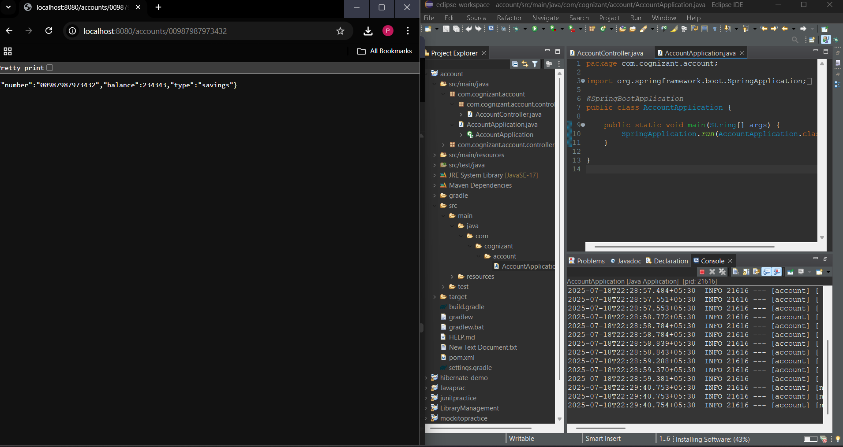

2)loan

package com.cognizant.loan.controller;

import org.springframework.web.bind.annotation.GetMapping;

import org.springframework.web.bind.annotation.PathVariable;

import org.springframework.web.bind.annotation.RestController;

import java.util.HashMap;

import java.util.Map;

*@RestController*

public class LoanController {

*@GetMapping*("/loans/{number}")

public Map<String, Object> getLoanDetails(*@PathVariable* String number) {

Map<String, Object> response = new HashMap<>();

response.put("number", number);

response.put("type", "car");

response.put("loan", 400000);

response.put("emi", 3258);

response.put("tenure", 18);

return response;

}

}

